***Bank Management System:***

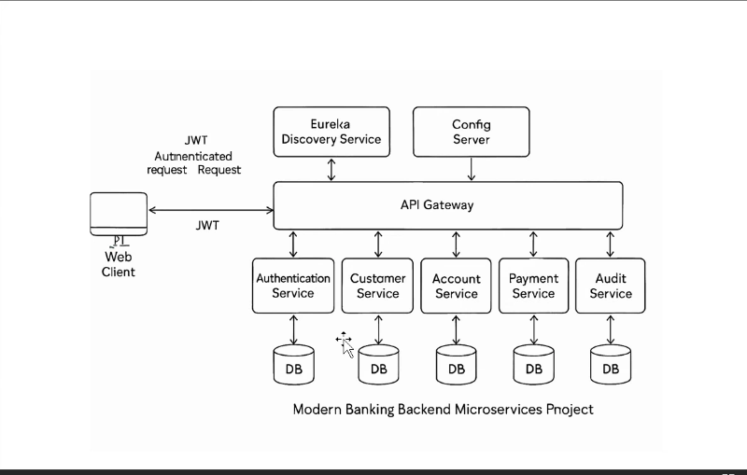Architecture :

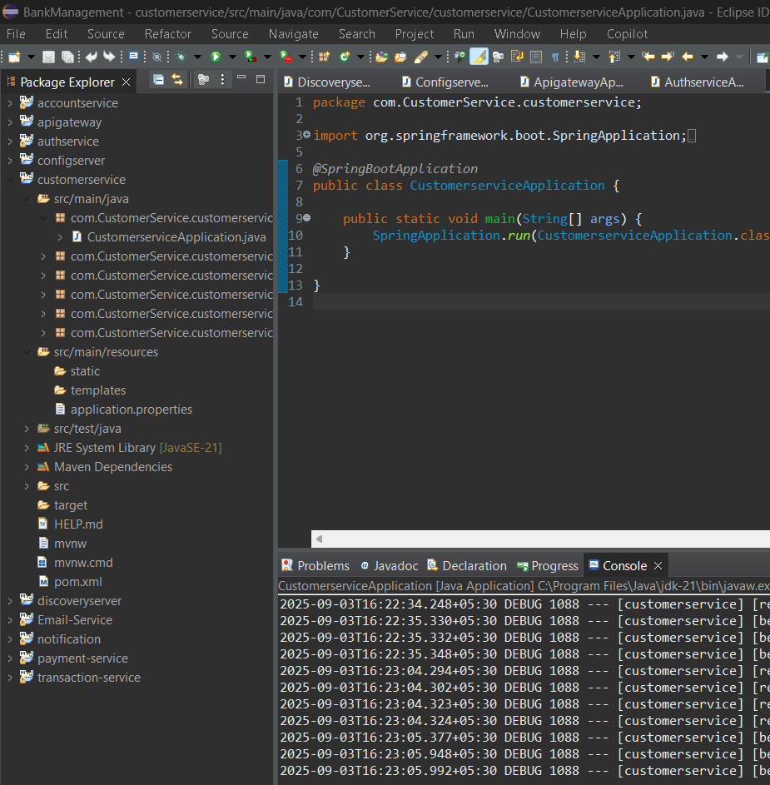Backend:

**📑 API Access Documentation**

**🔑 Auth Service (/auth)**

* POST /auth/register → **PUBLIC** (anyone can register)
* POST /auth/login → **PUBLIC** (anyone can login)

**👥 Customer Service (/api/customers)**

* GET /api/customers → **ADMIN only** (view all customers)
* GET /api/customers/{id} →
  + **ADMIN** → Can view any customer
  + **USER** → Can only view their own profile (matched by email)
* POST /api/customers → **USER only** (create profile, requires X-Auth-UserId)
* DELETE /api/customers/{id} → **ADMIN only** (delete customer)
* GET /api/customers/user/{userId} → **INTERNAL / ADMIN** (used for linking accounts, no role check here)

**💳 Account Service (/accounts)**

* POST /accounts → **ADMIN only** (create account)
* GET /accounts/my → **USER only** (view their own accounts, via linked customers)
* GET /accounts → **ADMIN only** (view all accounts)
* DELETE /accounts/{id} → **ADMIN only** (delete account)
* GET /accounts/customer/{customerId} → **ADMIN / INTERNAL** (no role check, used internally)
* POST /accounts/transfer → **USER only** (transfer money between accounts)

**💸 Payment Service (/payments)**

* POST /payments/transfer → **USER only** (transfer between their accounts)
* GET /payments/my/{accountId} → **USER only** (view own transactions)
* GET /payments → **ADMIN only** (view all transactions)

**🔔 Notification Service using Kafka(/notifications)**

* POST /notifications/send → **PUBLIC / INTERNAL** (no role check, used to send notifications)

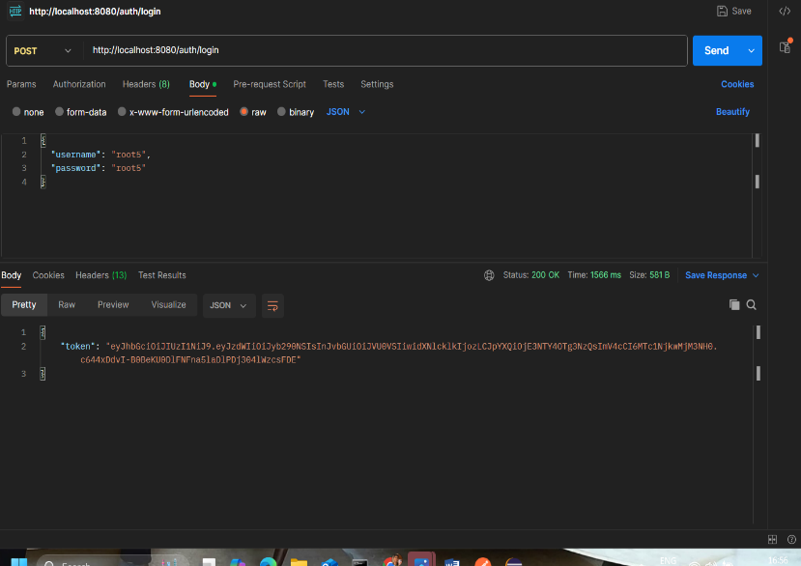Postman Testing:

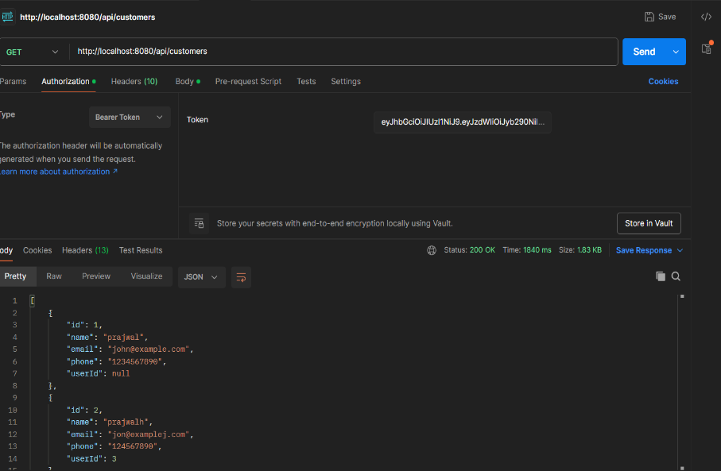

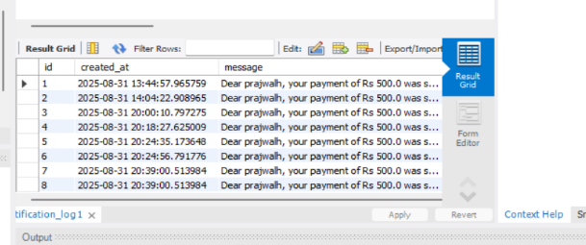Database:  
  
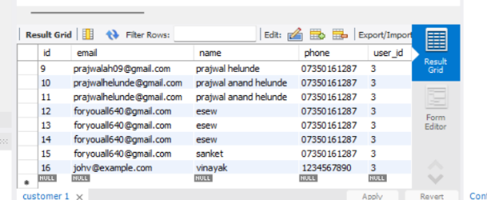

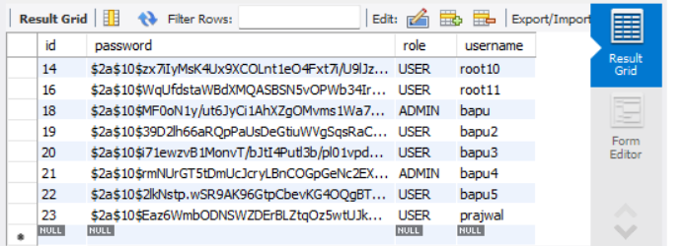

Frontend Implementation:

Admin:

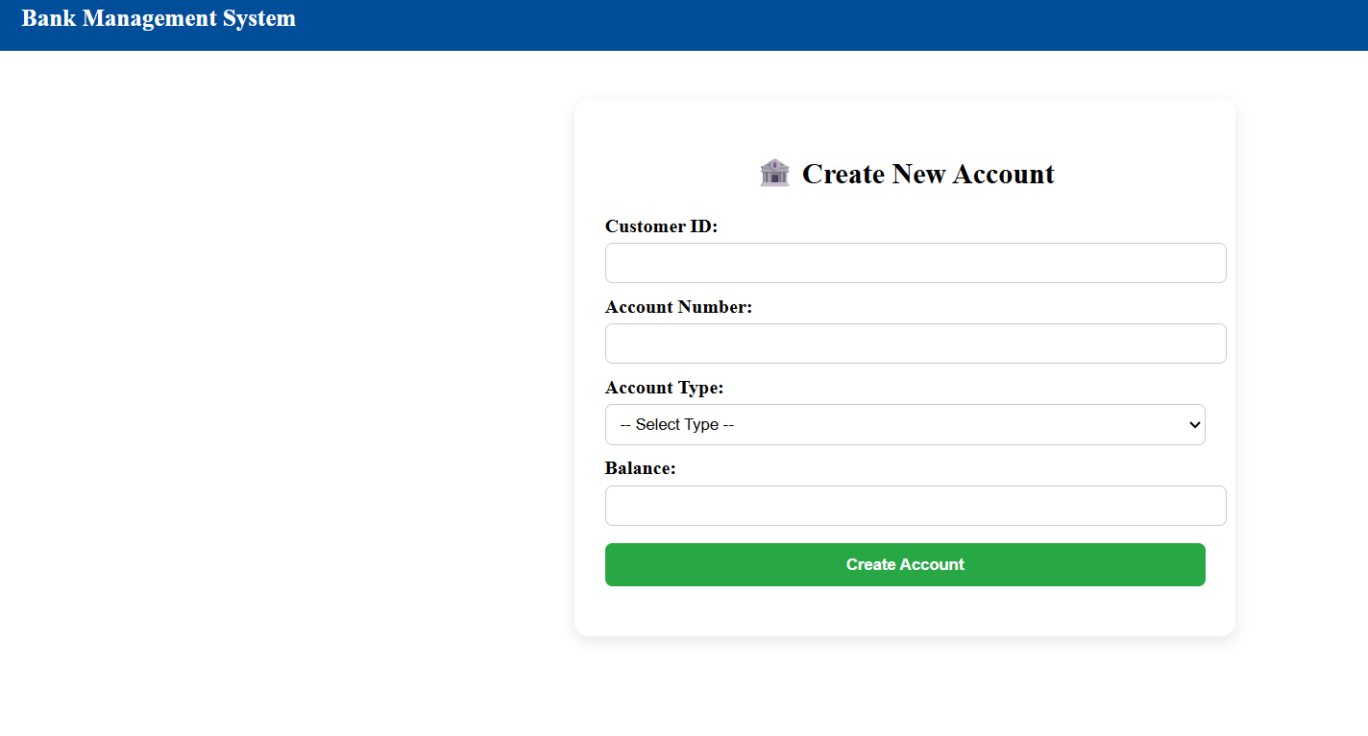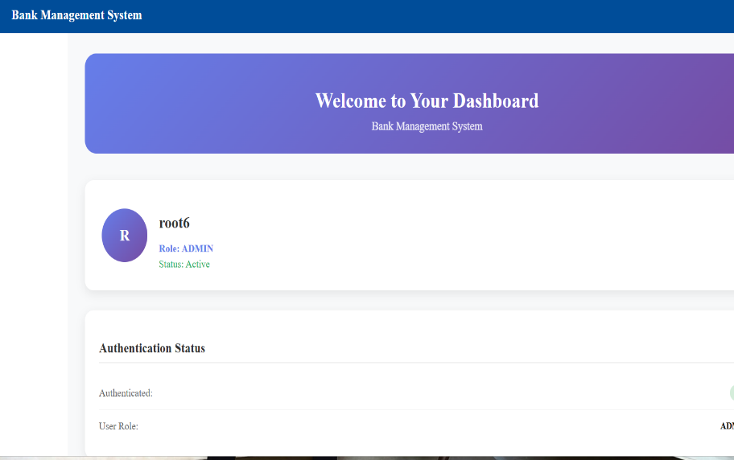

User:

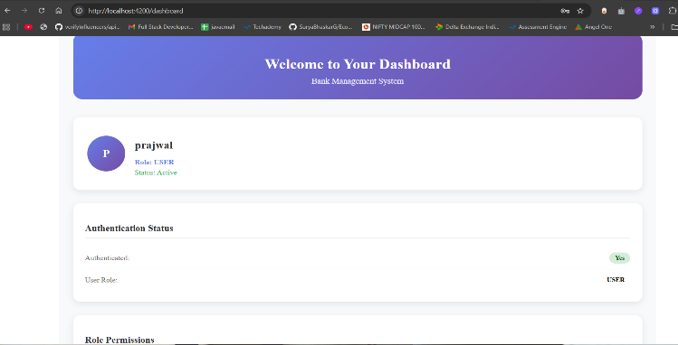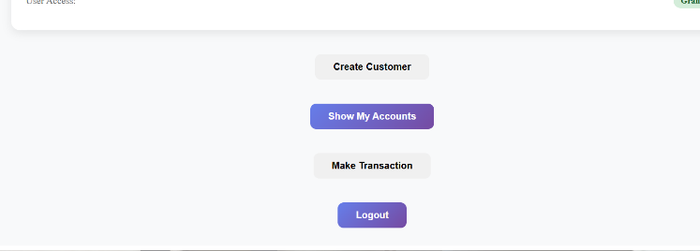

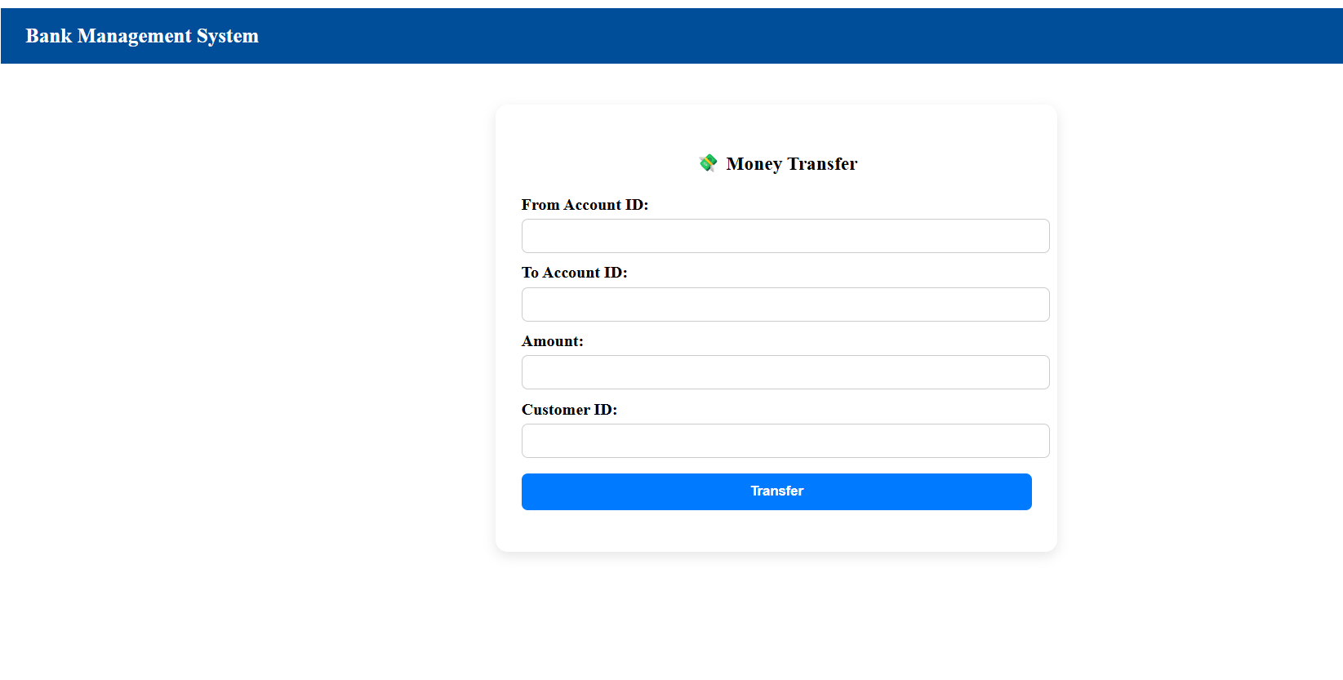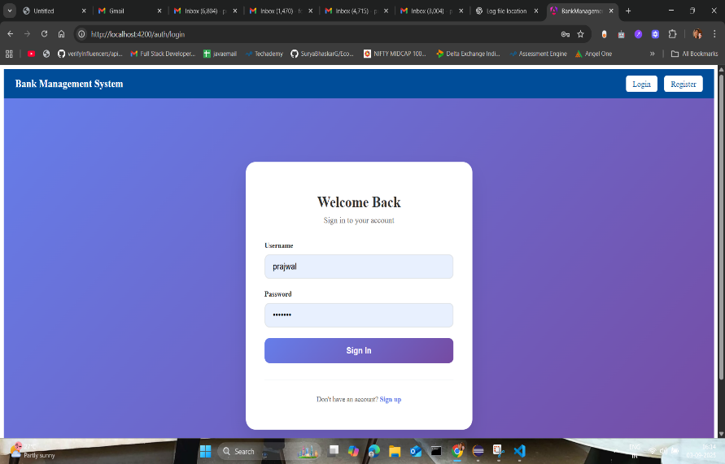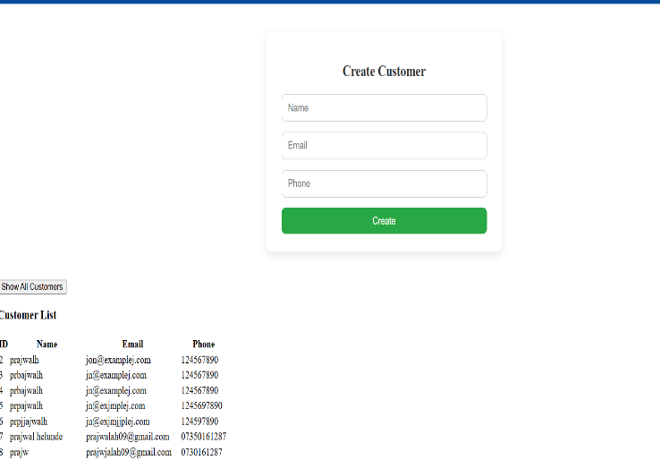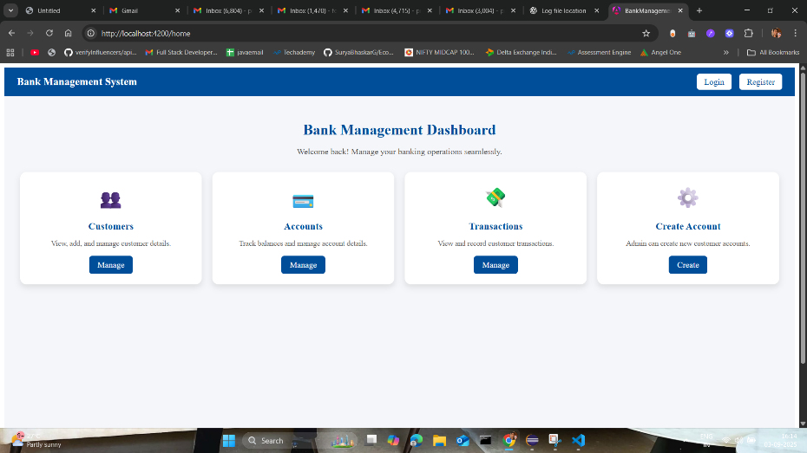

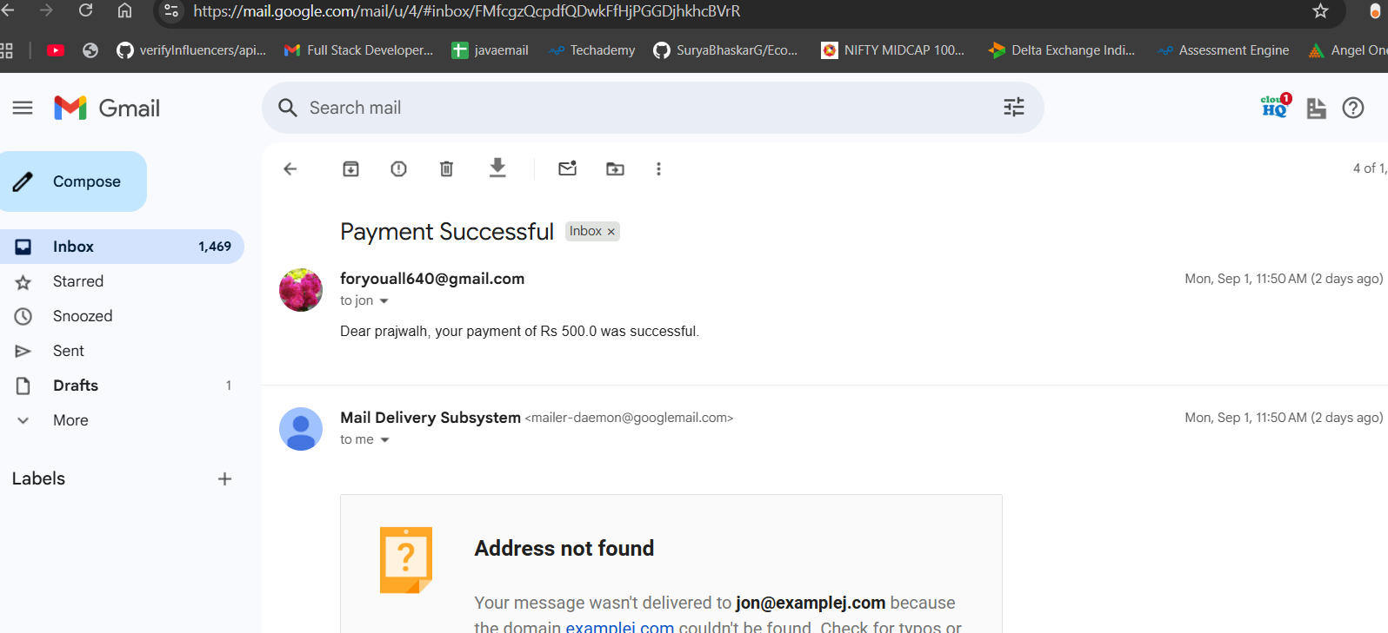Notification : (using kafka)